**Fase de diseño de un supermercado**

**Nizar Sanchez-(2018-6482)**

**Diagrama de caso de uso**

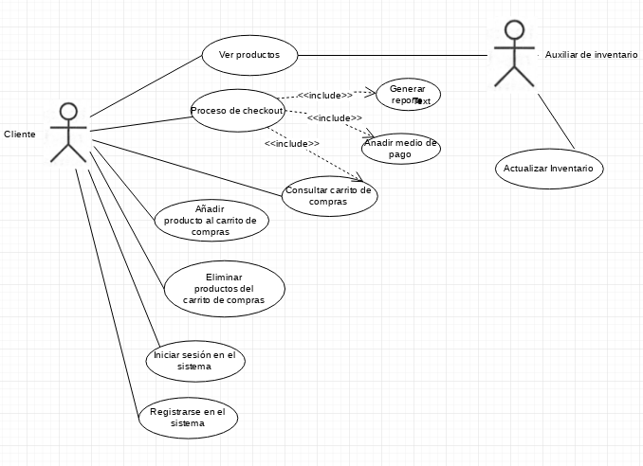

**Diagrama de secuencia:**

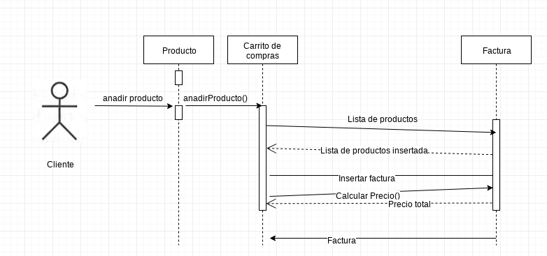

**Modelo E/R**

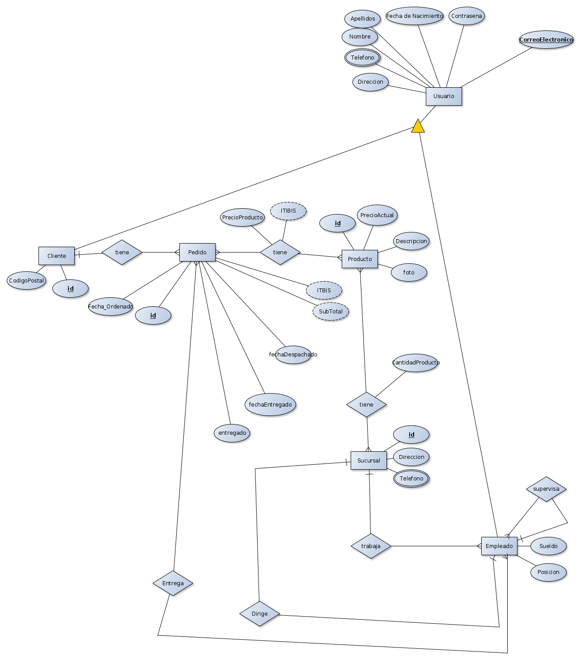

**Modelo Relacional**

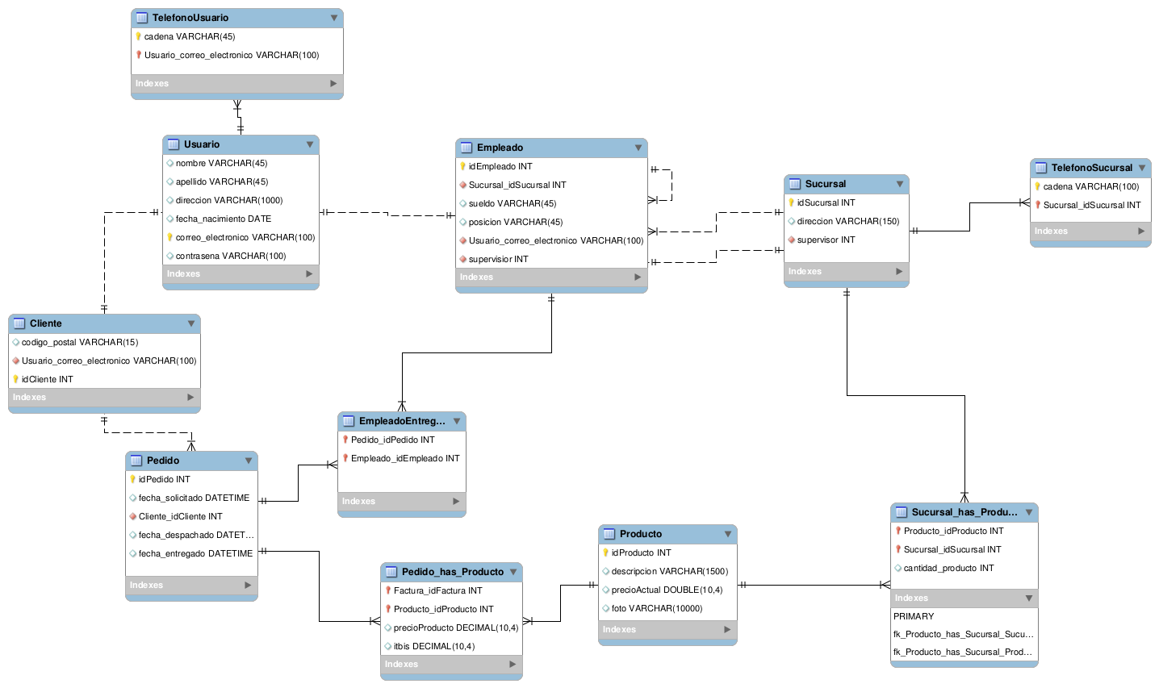

**Modelo Fisico**

**-- MySQL Script generated by MySQL Workbench**

**-- Mon 25 Nov 2019 10:38:47 AM AST**

**-- Model: New Model Version: 1.0**

**-- MySQL Workbench Forward Engineering**

**SET @OLD_UNIQUE_CHECKS=@@UNIQUE_CHECKS, UNIQUE_CHECKS=0;**

**SET @OLD_FOREIGN_KEY_CHECKS=@@FOREIGN_KEY_CHECKS, FOREIGN_KEY_CHECKS=0;**

**SET @OLD_SQL_MODE=@@SQL_MODE, SQL_MODE='TRADITIONAL,ALLOW_INVALID_DATES';**

**-- -----------------------------------------------------**

**-- Schema mydb**

**-- -----------------------------------------------------**

**-- -----------------------------------------------------**

**-- Schema mydb**

**-- -----------------------------------------------------**

**CREATE SCHEMA IF NOT EXISTS `mydb` DEFAULT CHARACTER SET utf8 ;**

**USE `mydb` ;**

**-- -----------------------------------------------------**

**-- Table `mydb`.`table1`**

**-- -----------------------------------------------------**

**CREATE TABLE IF NOT EXISTS `mydb`.`table1` (**

**)**

**ENGINE = InnoDB;**

**-- -----------------------------------------------------**

**-- Table `mydb`.`Usuario`**

**-- -----------------------------------------------------**

**CREATE TABLE IF NOT EXISTS `mydb`.`Usuario` (**

**`nombre` VARCHAR(45) NULL,**

**`apellido` VARCHAR(45) NULL,**

**`direccion` VARCHAR(1000) NULL,**

**`fecha_nacimiento` DATE NULL,**

**`correo_electronico` VARCHAR(100) NOT NULL,**

**`contrasena` VARCHAR(100) NULL,**

**PRIMARY KEY (`correo_electronico`))**

**ENGINE = InnoDB;**

**-- -----------------------------------------------------**

**-- Table `mydb`.`TelefonoUsuario`**

**-- -----------------------------------------------------**

**CREATE TABLE IF NOT EXISTS `mydb`.`TelefonoUsuario` (**

**`cadena` VARCHAR(45) NOT NULL,**

**`Usuario_correo_electronico` VARCHAR(100) NOT NULL,**

**PRIMARY KEY (`cadena`, `Usuario_correo_electronico`),**

**INDEX `fk_TelefonoUsuario_Usuario1_idx` (`Usuario_correo_electronico` ASC),**

**CONSTRAINT `fk_TelefonoUsuario_Usuario1`**

**FOREIGN KEY (`Usuario_correo_electronico`)**

**REFERENCES `mydb`.`Usuario` (`correo_electronico`)**

**ON DELETE NO ACTION**

**ON UPDATE NO ACTION)**

**ENGINE = InnoDB;**

**-- -----------------------------------------------------**

**-- Table `mydb`.`Cliente`**

**-- -----------------------------------------------------**

**CREATE TABLE IF NOT EXISTS `mydb`.`Cliente` (**

**`codigo_postal` VARCHAR(15) NULL,**

**`Usuario_correo_electronico` VARCHAR(100) NOT NULL,**

**`idCliente` INT NOT NULL,**

**INDEX `fk_Cliente_Usuario1_idx` (`Usuario_correo_electronico` ASC),**

**PRIMARY KEY (`idCliente`),**

**CONSTRAINT `fk_Cliente_Usuario1`**

**FOREIGN KEY (`Usuario_correo_electronico`)**

**REFERENCES `mydb`.`Usuario` (`correo_electronico`)**

**ON DELETE NO ACTION**

**ON UPDATE NO ACTION)**

**ENGINE = InnoDB;**

**-- -----------------------------------------------------**

**-- Table `mydb`.`Producto`**

**-- -----------------------------------------------------**

**CREATE TABLE IF NOT EXISTS `mydb`.`Producto` (**

**`idProducto` INT NOT NULL AUTO_INCREMENT,**

**`descripcion` VARCHAR(1500) NULL,**

**`precioActual` DOUBLE(10,4) NULL,**

**`foto` VARCHAR(10000) NULL,**

**PRIMARY KEY (`idProducto`))**

**ENGINE = InnoDB;**

**-- -----------------------------------------------------**

**-- Table `mydb`.`Pedido`**

**-- -----------------------------------------------------**

**CREATE TABLE IF NOT EXISTS `mydb`.`Pedido` (**

**`idPedido` INT NOT NULL AUTO_INCREMENT,**

**`fecha_solicitado` DATETIME NULL,**

**`Cliente_idCliente` INT NOT NULL,**

**`fecha_despachado` DATETIME NULL,**

**`fecha_entregado` DATETIME NULL,**

**PRIMARY KEY (`idPedido`),**

**INDEX `fk_Pedido_Cliente1_idx` (`Cliente_idCliente` ASC),**

**CONSTRAINT `fk_Pedido_Cliente1`**

**FOREIGN KEY (`Cliente_idCliente`)**

**REFERENCES `mydb`.`Cliente` (`idCliente`)**

**ON DELETE NO ACTION**

**ON UPDATE NO ACTION)**

**ENGINE = InnoDB;**

**-- -----------------------------------------------------**

**-- Table `mydb`.`Pedido_has_Producto`**

**-- -----------------------------------------------------**

**CREATE TABLE IF NOT EXISTS `mydb`.`Pedido_has_Producto` (**

**`Factura_idFactura` INT NOT NULL,**

**`Producto_idProducto` INT NOT NULL,**

**`precioProducto` DECIMAL(10,4) NULL,**

**`itbis` DECIMAL(10,4) NULL,**

**PRIMARY KEY (`Factura_idFactura`, `Producto_idProducto`),**

**INDEX `fk_Factura_has_Producto_Producto1_idx` (`Producto_idProducto` ASC),**

**INDEX `fk_Factura_has_Producto_Factura1_idx` (`Factura_idFactura` ASC),**

**CONSTRAINT `fk_Factura_has_Producto_Factura1`**

**FOREIGN KEY (`Factura_idFactura`)**

**REFERENCES `mydb`.`Pedido` (`idPedido`)**

**ON DELETE NO ACTION**

**ON UPDATE NO ACTION,**

**CONSTRAINT `fk_Factura_has_Producto_Producto1`**

**FOREIGN KEY (`Producto_idProducto`)**

**REFERENCES `mydb`.`Producto` (`idProducto`)**

**ON DELETE NO ACTION**

**ON UPDATE NO ACTION)**

**ENGINE = InnoDB;**

**-- -----------------------------------------------------**

**-- Table `mydb`.`Empleado`**

**-- -----------------------------------------------------**

**CREATE TABLE IF NOT EXISTS `mydb`.`Empleado` (**

**`idEmpleado` INT NOT NULL AUTO_INCREMENT,**

**`Sucursal_idSucursal` INT NOT NULL,**

**`sueldo` VARCHAR(45) NULL,**

**`posicion` VARCHAR(45) NULL,**

**`Usuario_correo_electronico` VARCHAR(100) NOT NULL,**

**`supervisior` INT NOT NULL,**

**PRIMARY KEY (`idEmpleado`),**

**INDEX `fk_Empleado_Sucursal1_idx` (`Sucursal_idSucursal` ASC),**

**INDEX `fk_Empleado_Usuario1_idx` (`Usuario_correo_electronico` ASC),**

**INDEX `fk_Empleado_Empleado1_idx` (`supervisior` ASC),**

**CONSTRAINT `fk_Empleado_Sucursal1`**

**FOREIGN KEY (`Sucursal_idSucursal`)**

**REFERENCES `mydb`.`Sucursal` (`idSucursal`)**

**ON DELETE NO ACTION**

**ON UPDATE NO ACTION,**

**CONSTRAINT `fk_Empleado_Usuario1`**

**FOREIGN KEY (`Usuario_correo_electronico`)**

**REFERENCES `mydb`.`Usuario` (`correo_electronico`)**

**ON DELETE NO ACTION**

**ON UPDATE NO ACTION,**

**CONSTRAINT `fk_Empleado_Empleado1`**

**FOREIGN KEY (`supervisior`)**

**REFERENCES `mydb`.`Empleado` (`idEmpleado`)**

**ON DELETE NO ACTION**

**ON UPDATE NO ACTION)**

**ENGINE = InnoDB;**

**-- -----------------------------------------------------**

**-- Table `mydb`.`Sucursal`**

**-- -----------------------------------------------------**

**CREATE TABLE IF NOT EXISTS `mydb`.`Sucursal` (**

**`idSucursal` INT NOT NULL AUTO_INCREMENT,**

**`direccion` VARCHAR(150) NULL,**

**`supervisor` INT NOT NULL,**

**PRIMARY KEY (`idSucursal`),**

**INDEX `fk_Sucursal_Empleado1_idx` (`supervisor` ASC),**

**CONSTRAINT `fk_Sucursal_Empleado1`**

**FOREIGN KEY (`supervisor`)**

**REFERENCES `mydb`.`Empleado` (`idEmpleado`)**

**ON DELETE NO ACTION**

**ON UPDATE NO ACTION)**

**ENGINE = InnoDB;**

**-- -----------------------------------------------------**

**-- Table `mydb`.`Sucursal_has_Producto`**

**-- -----------------------------------------------------**

**CREATE TABLE IF NOT EXISTS `mydb`.`Sucursal_has_Producto` (**

**`Producto_idProducto` INT NOT NULL,**

**`Sucursal_idSucursal` INT NOT NULL,**

**`cantidad_producto` INT NULL,**

**PRIMARY KEY (`Producto_idProducto`, `Sucursal_idSucursal`),**

**INDEX `fk_Producto_has_Sucursal_Sucursal1_idx` (`Sucursal_idSucursal` ASC),**

**INDEX `fk_Producto_has_Sucursal_Producto1_idx` (`Producto_idProducto` ASC),**

**CONSTRAINT `fk_Producto_has_Sucursal_Producto1`**

**FOREIGN KEY (`Producto_idProducto`)**

**REFERENCES `mydb`.`Producto` (`idProducto`)**

**ON DELETE NO ACTION**

**ON UPDATE NO ACTION,**

**CONSTRAINT `fk_Producto_has_Sucursal_Sucursal1`**

**FOREIGN KEY (`Sucursal_idSucursal`)**

**REFERENCES `mydb`.`Sucursal` (`idSucursal`)**

**ON DELETE NO ACTION**

**ON UPDATE NO ACTION)**

**ENGINE = InnoDB;**

**-- -----------------------------------------------------**

**-- Table `mydb`.`EmpleadoEntregaPedido`**

**-- -----------------------------------------------------**

**CREATE TABLE IF NOT EXISTS `mydb`.`EmpleadoEntregaPedido` (**

**`Pedido_idPedido` INT NOT NULL,**

**`Empleado_idEmpleado` INT NOT NULL,**

**PRIMARY KEY (`Pedido_idPedido`, `Empleado_idEmpleado`),**

**INDEX `fk_Pedido_has_Empleado_Empleado1_idx` (`Empleado_idEmpleado` ASC),**

**INDEX `fk_Pedido_has_Empleado_Pedido1_idx` (`Pedido_idPedido` ASC),**

**CONSTRAINT `fk_Pedido_has_Empleado_Pedido1`**

**FOREIGN KEY (`Pedido_idPedido`)**

**REFERENCES `mydb`.`Pedido` (`idPedido`)**

**ON DELETE NO ACTION**

**ON UPDATE NO ACTION,**

**CONSTRAINT `fk_Pedido_has_Empleado_Empleado1`**

**FOREIGN KEY (`Empleado_idEmpleado`)**

**REFERENCES `mydb`.`Empleado` (`idEmpleado`)**

**ON DELETE NO ACTION**

**ON UPDATE NO ACTION)**

**ENGINE = InnoDB;**

**-- -----------------------------------------------------**

**-- Table `mydb`.`TelefonoSucursal`**

**-- -----------------------------------------------------**

**CREATE TABLE IF NOT EXISTS `mydb`.`TelefonoSucursal` (**

**`cadena` VARCHAR(100) NOT NULL COMMENT 'k',**

**`Sucursal_idSucursal` INT NOT NULL,**

**PRIMARY KEY (`cadena`, `Sucursal_idSucursal`),**

**INDEX `fk_TelefonoSucursal_Sucursal1_idx` (`Sucursal_idSucursal` ASC),**

**CONSTRAINT `fk_TelefonoSucursal_Sucursal1`**

**FOREIGN KEY (`Sucursal_idSucursal`)**

**REFERENCES `mydb`.`Sucursal` (`idSucursal`)**

**ON DELETE NO ACTION**

**ON UPDATE NO ACTION)**

**ENGINE = InnoDB;**

**SET SQL_MODE=@OLD_SQL_MODE;**

**SET FOREIGN_KEY_CHECKS=@OLD_FOREIGN_KEY_CHECKS;**

**SET** [**UNIQUE_CHECKS=@OLD_UNIQUE_CHECKS**](mailto:UNIQUE_CHECKS%3D@OLD_UNIQUE_CHECKS)**;**

**Diccionario de datos:**



. DISEÑO DE SALIDA DEL SISTEMA, ENTRADA DE DATOS E INTERFACES DEL USUARIO(MENÚ Y LOGIN)

